**WEEK – 10**

**1#** Program to sort array in ascending order

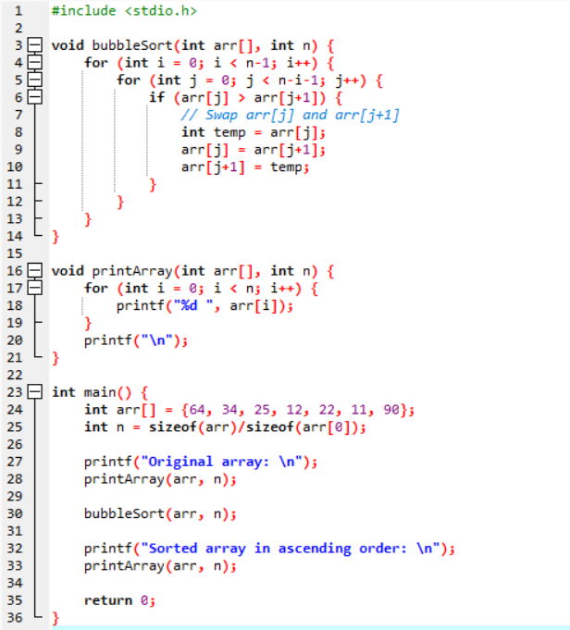

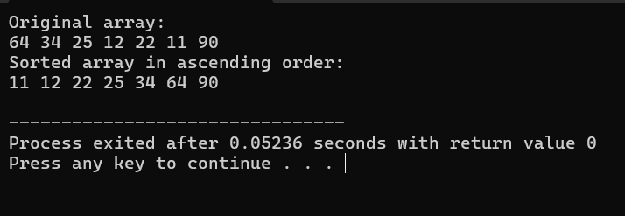

**2#** Write a program in C to add two matrices of order N. You should also mention the necessary condition for matrix addition

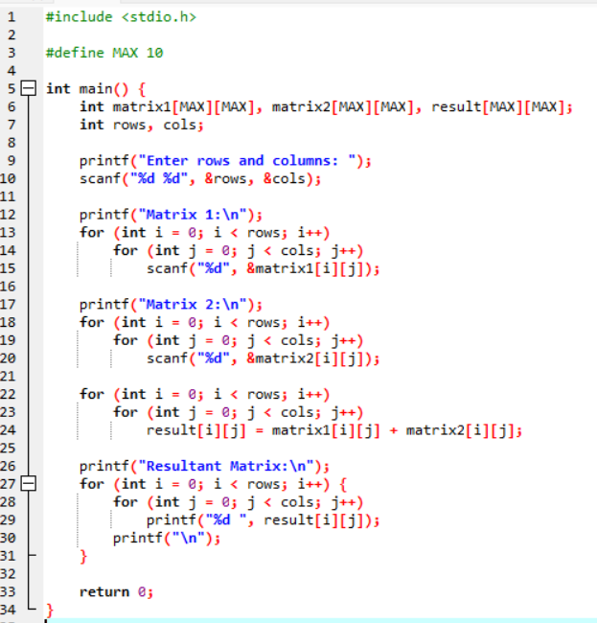

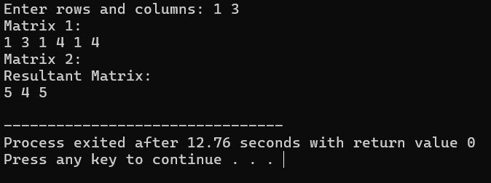

**3#** Write a program in C to find the transpose of a given matrix

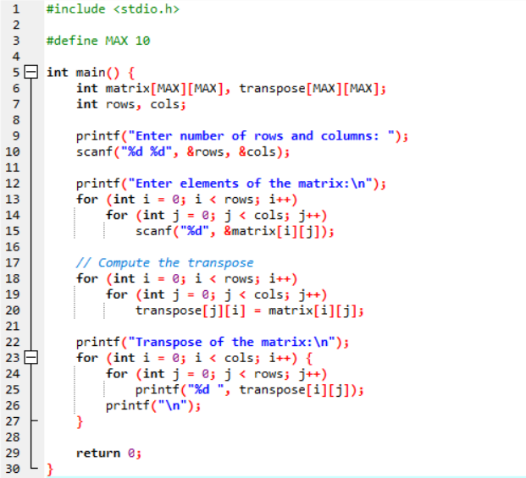

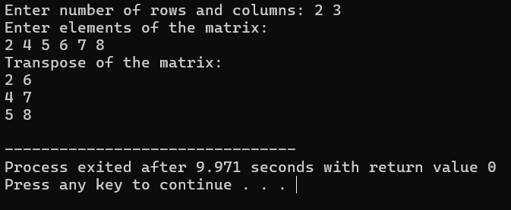

**4#** Write a program in C to print the lower triangular and upper triangular matrix of a given matrix

